**Nutrition Assistant Application**

**Abstract**

Lack of proper diet causes many diseases like night blindness, gum death, rickets, osteomalacia, etc. Similarly, undernutrition will cause a low intelligence quotient (IQ), osteoporosis, anemia, scurvy, pellagra, etc. Over-nutrition will result in obesity, Type II diabetes mellitus, and ischemic heart diseases. Also, the unhygienic intake of food, intake of food on no fixed time, intake of fast food intake of other unhealthy stuff can lead to irregularities in the human body. Adopting healthy habits, physical activity, exercise, sports, and walking can lead to a healthy lifestyle of an individual. In addition, today's busy schedule and less time availability restricts individuals to visit the doctors or nutritionists. Many mobile applications were developed for monitoring and calculating an energy level as well as healthy nutrition. This project aims at building a web App that automatically estimates food attributes such as ingredients and nutritional value by classifying the input image of food. This app will analyze real-time images of a meal and analyze it for nutritional content which can be very handy and improves the dietary habits, and therefore, helps in maintaining a healthy lifestyle.

**Introduction**

Have you been wondering how many calories you consume in a day or your daily protein intake? Well, most people are becoming conscious of what they are eating and how many calories they consume on a regular basis. Keeping track of your dietary intake and physical activity is difficult. As per World Obesity approximately 2.7 billion adults get obese and around 177 million adults will severly gets affected by 2025.

These stats show that we are living in the dark times and the agenda of Health & Fitness is in desperate need of a push. You can see this push in the form of increasing number of Gyms and nutrition centres across the world.

Gyms have been a huge success. However, everybody doesn’t have the time to join the gym. Moreover, some do join on the New Year’s Eve and then procrastinate for the rest of year.

For such audiences, the diet & fitness app is a saviour. They assist the users to follow a proper diet and to keep build Health and Fitness Apps a check on their calorie intake.

To take full advantage of the situation mobile app development firms have started to. Some apps are already doing well by helping app users at their best however, there are so many opportunities left for you to explore.

However, you can keep a tab on the nutrition intake on a daily basis by using diet and nutrition tracking apps. These calories and fitness tracking mobile apps have proved to be quite beneficial to health-conscious people. With increased awareness about health and fitness, these apps have started gaining popularity.

[**Lose it**](https://www.loseit.com/)  is an nutrition based app. It is an efficient nutrition planner that offers a simple and basic method of keeping a track of your diet and physical activity. Its database includes thousands of food names and food recipes from restaurants all across the globe. These food recipes and food items are suggested by the nutrition team of Lose it. Apart from this Lose it keeps a track of all the macronutrients of a user.

It has a superb database of a large number of food products and activities and the fun part is that you have the option of adding some new ones by yourself. Keeps a proper track of all your macronutrients (proteins, fats, carbohydrates, fiber).

Nutrition based app on market are efficient and good rated but these app has their own food recipes uploaded on their database but they don’t show the nutrition fact of user foods. This drawback is overcome by nutrition assistance app. In which user upload foods image. The image is passed to the server application, which uses **Clarifai's AI-Driven Food Detection** **Model Service** to analyze the images and Nutrition API to provide nutritional information about the analyzed Image.

**Modules of the project**

**Clarifai's AI-Driven Food Detection** **Model Service**

**Clarifai Inc.** is an [artificial intelligence](https://en.wikipedia.org/wiki/Artificial_intelligence) (AI) company that specializes in [computer vision](https://en.wikipedia.org/wiki/Computer_vision) and uses [machine learning](https://en.wikipedia.org/wiki/Machine_learning) and [deep neural networks](https://en.wikipedia.org/wiki/Deep_learning#Deep_neural_networks) to identify and analyze images and videos. The company offers its solution[[*buzzword*](https://en.wikipedia.org/wiki/Wikipedia:Use_plain_English#Buzzwords)] via [API](https://en.wikipedia.org/wiki/Application_programming_interface), mobile [SDK](https://en.wikipedia.org/wiki/Software_development_kit), and [on-premise](https://en.wikipedia.org/wiki/On-premises_software) solutions.

Clarifai’s is AI driven which analyse the user image and predict the ingredient in the food.

**Nutrition API**

A nutrition API is **an online collection of food-related data that developers can access their apps and websites**.

**Kubernetes API**

The core of Kubernetes' [control plane](https://kubernetes.io/docs/reference/glossary/?all=true#term-control-plane) is the [API server](https://kubernetes.io/docs/concepts/overview/components/#kube-apiserver). The API server exposes an HTTP API that lets end users, different parts of your cluster, and external components communicate with one another.

The Kubernetes API lets you query and manipulate the state of API objects in Kubernetes (for example: Pods, Namespaces, ConfigMaps, and Events).

Most operations can be performed through the [kubectl](https://kubernetes.io/docs/reference/kubectl/) command-line interface or other command-line tools, such as [kubeadm](https://kubernetes.io/docs/reference/setup-tools/kubeadm/), which in turn use the API. However, you can also access the API directly using REST calls.

Consider using one of the [client libraries](https://kubernetes.io/docs/reference/using-api/client-libraries/) if you are writing an application using the Kubernetes API.

**IBM Container Registry**

Container Registry is a single place for our team **to manage Docker images, perform vulnerability analysis, and decide who can access what with fine-grained access control**. Existing CI/CD integrations let you set up fully automated Docker pipelines to get fast feedback.

A Docker registry is **a storage and distribution system for named Docker images**. The same image might have multiple different versions, identified by their tags. A Docker registry is organized into Docker repositories, where a repository holds all the versions of a specific image.

**Technical Architecture**

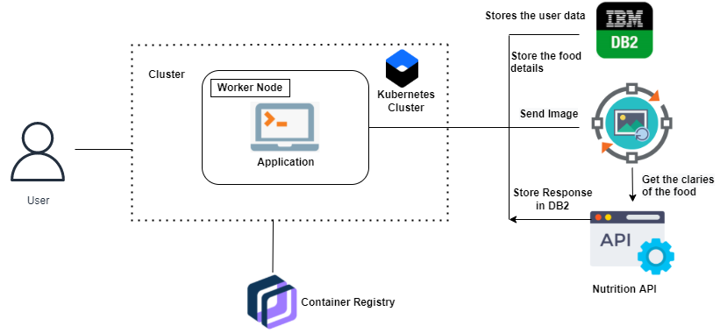

**Conclusion**

This paper presented complete review of the development of the nutrition application. We also examine all the history of the system which has nutrition application and discuss all the details of modules of our nutrition assistant web application. We study the specialized survey of AI driven for detecting the ingredient of foods in the image.

**Reference**

1. *Tilley, Aaron.*[*"Every AI Powerhouse Wanted This Whiz Kid. He's Taking Them on Instead"*](https://www.forbes.com/sites/aarontilley/2017/07/13/clarifai-ai-image-recognition/)*. Forbes. Retrieved January 31, 2018.*
2. [**^**](https://en.wikipedia.org/wiki/Clarifai#cite_ref-2) [*"How Matthew Zeiler Created 'Clarifai' – The Image And Video Recognition API For Building Smart Apps"*](http://www.crazyengineers.com/threads/how-matthew-zeiler-created-clarifai-the-image-and-video-recognition-api-for-building-smart-apps.95813/)*. CrazyEngineers. Retrieved January 31, 2018.*
3. [**^**](https://en.wikipedia.org/wiki/Clarifai#cite_ref-3) *Gershgorn, Dave.*[*"The data that transformed AI research—and possibly the world"*](https://qz.com/1034972/the-data-that-changed-the-direction-of-ai-research-and-possibly-the-world/)*. Quartz. Retrieved May 22, 2018.*
4. [**^**](https://en.wikipedia.org/wiki/Clarifai#cite_ref-4) [*"The AI Startup Google Should Probably Snatch Up Fast"*](https://www.wired.com/2014/07/clarifai/)*. WIRED. Retrieved May 22, 2018.*

5. Diet & Nutrition Tracking App Development Cost & Features [AUGUST 17, 2020](https://www.emizentech.com/blog/diet-nutrition-tracking-app-development.html)